

**A**

**CAPSTONE PROJECT REPORT**

**ON**

**“HEALTH MONITORING SYSTEM USING IOT”**

PROJECT WORK SUBMITTED IN PARTIAL FULFILLMENT OF THE

REQUIREMENTS FOR THE AWARD OF

**DIPLOMA IN**

**ELECTRONICS AND TELECOMMUNICATION ENGINEERING**

SUBMITTED BY

“**YOGITA MAHESH MADHAV**”

**“SHWETA HARIBHAU TAPKIR**”

UNDER THE GUIDANCE OF

**“SANJEET KUMAR SINGH**”



**Maharashtra State Board of Technical Education, Mumbai**

**Academic Year (2020-2021)**



# **CERTIFICATE**

This is to certify that,

|  |  |  |
| --- | --- | --- |
| **Roll No** | **Student Name** | **Enrollment No.** |
| 07 | Ms. Yogita Mahesh Madhav | 1805630150 |
| 38 | Ms. Shweta Haribhau Tapkir | 1905630422 |

From **Pravin Patil College of Diploma Engineering and Technology, Bhyander (E**) (Code: **0563**) has completed project of final year having title **Health monitoring system using iot** during the academic year 20**20** – 20**21**. The project completed in a group consisting of **two** persons under the guidance of the faculty Guide.

……………………………………

……………………………………

Name & Signature of Guide: ……………………………….

Telephone: ……………………………….

# **ACKNOWLEDGEMENT**

I express my sincere thanks to the Principal **Mrs. R.B Patil** , who has given me the opportunity to pursue my Diploma **Electronics and Telecommunication Engineering** department also express my thanks to H.O.D **Mrs. Rama Ranjankar** and **other staff of the Electronics And Telecommunication Engineering department**. I would like to thanks my guide **Mr. Sanjeet Kumar Singh** for her encouragement and guidance, which helped me in completing the project. I would like to thanks institute for providing me the opportunity to learn and observe the technical work. Finally I would like to thank my colleagues and friends who helped me in completing the Project successfully.

I would also like to express my heartfelt gratitude to my parents, teachers and friends for their direction, motivation and selfless support.

# **ABSTRACT**

Our model project name is health monitoring system using iot. Our system is designed to be used in hospitals and homes also for measuring and monitoring various parameters like body temperature, ECG, pulse oximeter, heart rate, air temperature and humidity. The primary goal was to develop a reliable patient monitoring system using IoT so that the healthcare professionals can monitor their patients, who are either hospitalized or at home using an IoT based integrated healthcare system with the view of ensuring patients are cared for better. The patient’s temperature, heart beat rate, SPO2 data are monitored, displayed and stored by the system and sent to the doctor’s mobile containing the application. Thus, IoT based patient monitoring system effectively monitor patient’s health status and save life on time.

# **TABLE OF CONTENTS**

**1.** **Introduction** 6

**1.1** **Background of the study** 6

**1.2** **Current Scenario** 7

**1.3** **Problem Faced in Current scenario** 8

**1.4** **Solution and Planning** 8

**2.** **Literature Review** 9

**3.** **Scope of Project** 11

**4.** **Methodology** 12

**4.1** **Purposed system** 12

**4.2** **Hardware requirement** 13

**4.3** **Software requirement** 19

**5.** **Designing** 20

**5.1** **Circuit Diagram** 20

**5.2** **Flow Chart** 21

**5.3** **Block diagram** 22

**6.** **Result and Applications** 23

**6.1** **Result** 23

**6.2** **Applications** 24

**7.** **Conclusion and Future Scope** 25

**7.1** **Conclusion** 25

**7.2 Future scope:** 26

**8.** **Appendix** 27

**9.** **References and Bibliography** 28

**9.1** **Reference** 28

**9.2** **Bibliography** 28

# **Introduction**

# **Background of the study**

What is a Remote Health Monitoring System?

A Remote health monitoring system is an extension of a hospital medical system where a patient’s vital body state can be monitored remotely. Traditionally the detection systems were only found in hospitals and were characterized by huge and complex circuitry which required high power consumption. Continuous advances in the semiconductor technology industry have led to sensors and microcontrollers that are smaller in size, faster in operation, low in power consumption and affordable in cost. This has further seen development in the remote monitoring of vital life signs of patients especially the elderly.

In recent times, several systems have come up to address the issue of remote health monitoring. The systems have a wireless detection system that sends the sensor information wirelessly to a remote server. Some even adopted a service model that requires one to pay a subscription fee. In developing countries, this is a hindrance as some people cannot use them due 2 to cost issue involved. There is also the issue of internet connectivity where some systems to operate, good quality internet for a real-time remote connection is required. Internet penetration is still a problem in developing countries. Many of the systems were introduced in the developed countries where the infrastructure is working perfectly. In most cases, the systems are adapted to work in developing countries. To reduce some of these problems there is need to approach the remote detection from a ground-up approach to suit the basic minimal conditions presently available in developing countries.

# **Current Scenario**

Healthcare has become one of India’s largest sector, both in terms of revenue and employment. Healthcare comprises hospitals, medical devices, clinical trials, outsourcing, telemedicine, medical tourism, health insurance and medical equipment. The Indian healthcare sector is growing at a brisk pace due to its strengthening coverage, services and increasing expenditure by public as well private players. Indian healthcare delivery system is categorized into two major components public and private. The Government, i.e. public healthcare system, comprises limited secondary and tertiary care institutions in key cities and focuses on providing basic healthcare facilities in the form of primary healthcare centers (PHCs) in rural areas. The private sector provides majority of secondary, tertiary, and quaternary care institutions with major concentration in metros and tier I and tier II cities. India's competitive advantage lies in its large pool of well-trained medical professionals. India is also cost competitive compared to its peers in Asia and Western countries. The cost of surgery in India is about one-tenth of that in the US or Western Europe.

About 80 per cent of doctors, 75 per cent of dispensaries and 60 per cent of hospitals are present in urban areas when 72 per cent of India's population lives in rural areas12. Rising healthcare costs is another major concern for India, with around 60 per cent13of the healthcare expenditure being out of pocket.

Health is always a major concern in every growth the human race is advancing in terms of technology. Like the recent corona virus attack that has ruined the economy of india to an extent is an example how health care has become of major importance. In such areas where the epidemic is spread, it is always a better idea to monitor these patients using remote health monitoring technology.

# **Problem Faced in Current scenario**

The main problem for the poor people is dangerous and emergency health care service at dangerous event. In today’s health care system for the patient who stays in home is not reactive so there is a need to develop the system which is respective in nature. Problem statement:

* no rapid medical sensor network has not been proposed
* need of a rapid diagnosis e-health care system
* doesn’t interrupt the human’s daily activities to predict and prevent diseases
* no proper systems which compliment health and patients environment
* Expensive Health Service

# **Solution and Planning**

Internet of Things (IoT) based health monitoring system is the current solution for it. Health monitoring system are playing vital role in hospitality. our system is designed to be used in hospitals and homes also for measuring and monitoring various parameters like temperature and blood pressure, ECG, pulse oximeter. The results can be recorded using esp8266 nodemcu. And doctor can monitor patient health parameter just by visiting website or app. Therefore, one main significant contribution of this study is that patients in self-isolation or self-quarantine can use the new platform to send daily health symptoms and challenges to doctors via their mobile phones. Thus, improved healthy living and a comfortable lifestyle can still be achieved even during such a problematic period of the COVID-19 pandemic. It helps in faster detection of input sensor. Patient health parameter data is stored over the cloud. So it is more beneficial than maintaining the records on printed papers kept in the files. Bridging the gap between the doctor and the patients. So best to be used on rural areas. Message to the doctor means immediate aid can be provided. This system is to be available at reasonable prices.

# **Literature Review**

S. J. Jung and W. Y. Chung studied the Flexible and scalable patient’s health monitoring system in 6LoWPAN. The main advantage of this enabling factor is the combination of some technologies and communications solution. The results of Internet of Things are synergetic activities gathered in various fields of knowledge like telecommunications, informatics and electronics. K. S. Shin and M. J. Mao Kaiver studied a cell phone based health monitoring system with self-analysis which incorporates IoT [13] a new paradigm that uses smart objects which are not only capable of collecting the information from the environment and interacting the physical world, but also to be interconnected with each other through internet to exchange data as well as information. Gennaro tartarisco and Tabilo Paniclo had studied a Maintaining sensing coverage and connectivity in large sensor networks mainly includes the information about how to build or develop a new computational technology based on clinical decision support systems, information processing, wireless communication and also data mining kept in new premises in the field of personal health care. Cristina Elena Turcua studied Health care applications a solution based on the Internet of Things survey aims to present a detailed information about how radio frequency identification, multi-agent and Internet of Things technologies can be used to develop and improve people’s access to quality and health care services and to optimize the health care process. Gubbi, Jayavardhana, Buyya, Rajkumar, Marusic, Slaven, Palaniswami, Marimuth studied the Internet of Things (IoT): A vision, architectural elements, and future direction which proposes on demand positioning and tracking system. It is based on Global Positioning enabled devices and suitable for large environments. Smart phones between two terminals are used for making initial communication. The initial communication is performed by synchronization phase. J.L. Kalju developed a system, which is capable of measuring different physiological parameters and are used to design a system for heart rate reconstruction for rate adaptive pacing. Loren Schwiebert, Sandeep K.S. Gupta and Jennifer Weinmann studied the strength of smart sensors which are developed from the combination of sensing materials along with combined circuitry for other biomedical applications. Gentili G.B proposed a simple microwave technique to monitor the cardiac activity. This technique is dependent on changes in modulation envelope of amplitude modulated waves passing through the body. It explained the use of wireless microsensors networks for medical monitoring and environmental sensing. Reza S.Dilmaghani(2016) in their study found the design of Wi-Fi sensor network that is capable of monitoring patient’s chronic diseases at their home itself via a remote monitoring system. So immerging of wireless sensor technology individual test like only blood pressure, heart rate, temperature etc. can be measured but this research project enables all this parameter together to be measured under single system, and also thus all can be worn by patient and processed data send toward internet through internet of things(IOT).

# **Scope of Project**

As the COVID-19 pandemic and shutdown kept people at home to avoid getting sick, especially those with chronic health conditions, experts recommended patient health monitoring as a solution to continuity of care.

Some of the benefits of the project:

* It is highly accurate and reliable.
* 24*7 health monitoring.
* It helps in faster detection of input sensor.
* It will reduce the extra consumption of electricity.
* No need for a bulky monitoring station.
* Easy to operate.
* Bridging the gap between the doctor and the patients.
* Best to be used on rural areas.
* It is a multipurpose so that overall condition are easily measured.
* Message to the doctor means immediate aid can be provided.
* This system is to be available at reasonable prices.
* Patient health parameter data is stored over the cloud. So it is more beneficial than maintaining the records on printed papers kept in the files.

# **Methodology**

# **Purposed system**

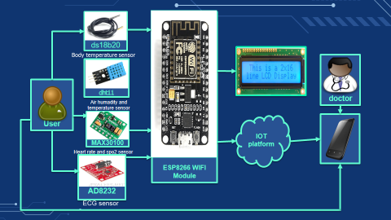**4.1.1 Block diagram of proposed system**

In these Health monitoring system, each sensor will perform their respective working at a time. In these ds18b20 sensor will can measure body temperature. The MAX30100 pulse oximiter sensor is an integrated pulse oximetry and heart-rate monitor sensor solution. The AD8232 ECG sensor is a neat little chip used to measure the electrical activity of the heart. This electrical activity can be charted as an ECG or Electrocardiogram. And dht11 sensor check air temperature and humidity of patient room. All these sensor data goes to the nodemcu esp8266 WiFi module. Esp8266 nodemcu module process the code. And display on lcd display and Android (using iot platform such as blynk, ubidots) so that patient health can be monitored from anywhere in the world over internet. And in several cases low/high blood pressure, temperature, pulse, low pulse oxygen monitored then alert message is sent to the doctor. All data save in Google sheets also using ifttt platform, patient health parameter data is stored over the Google sheet. So it is more beneficial than maintaining the records on printed papers kept in the files.

# **Hardware requirement**

1. **Node mcu esp8266**

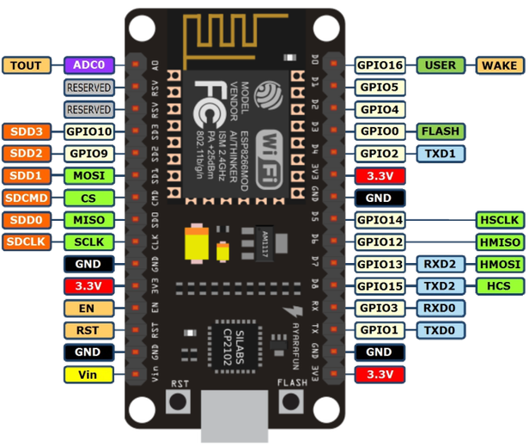

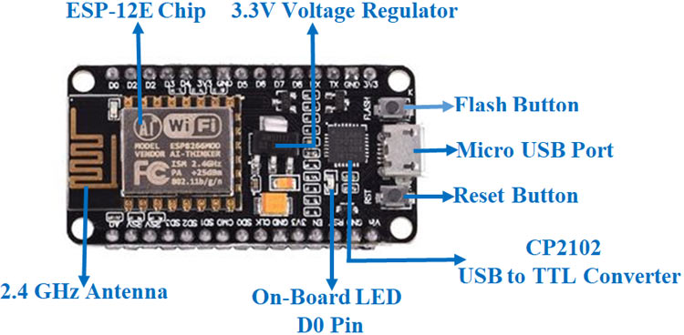

NodeMCU is an open-source Lua based firmware and development board specially targeted for IoT based Applications. It includes firmware that runs on the ESP8266 Wi-Fi SoC from Espressif Systems, and hardware which is based on the ESP-12 module.

* **NodeMCU ESP8266 Specifications & Features:**
* Microcontroller: Tensilica 32-bit RISC CPU Xtensa LX106
* Operating Voltage: 3.3V
* Input Voltage: 7-12V
* Digital I/O Pins (DIO): 16
* Analog Input Pins (ADC): 1
* UARTs: 1
* SPIs: 1
* I2Cs: 1
* Flash Memory: 4 MB
* SRAM: 64 KB
* Clock Speed: 80 MHz
* USB-TTL based on CP2102 is included onboard, Enabling Plug n Play
* PCB Antenna
* Small Sized module to fit smartly inside your IoT proje

1. **MAX30100**

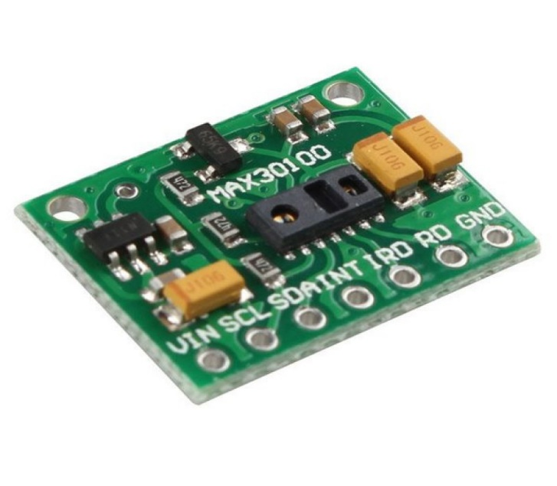

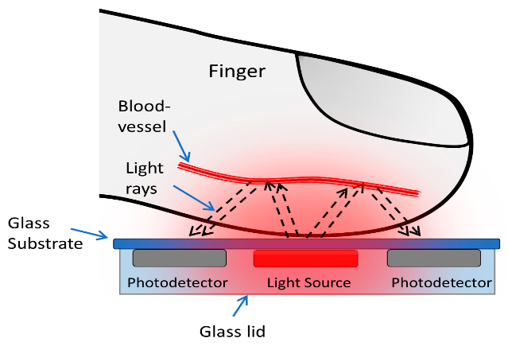

The MAX30100 is an integrated pulse oximetry and heart-rate monitor sensor solution. The device has two LEDs, one emitting a red light, another emitting infrared light. ... It turns out, oxygenated blood absorbs more infrared light and passes more red light while deoxygenated blood absorbs red light and passes more infrared light.This is the main function of the MAX30100: it reads the absorption levels for both light sources and stored them in a buffer that can be read via I2C. The pulse oximetry subsystem in MAX30100 consists of ambient light cancellation (ALC), 16-bit sigma delta ADC, and proprietary discrete time filter. It has an ultra-low-power operation which makes it ideal for battery operated systems. MAX30100 operates on a supply in the range of 1.8 to 3.3V. The MAX30100 operates from 1.8V and 3.3V power supplies and can be powered down through software with negligible standby current, permitting the power supply to remain connected at all times.

1. **DS18B20 Waterproof sensor**

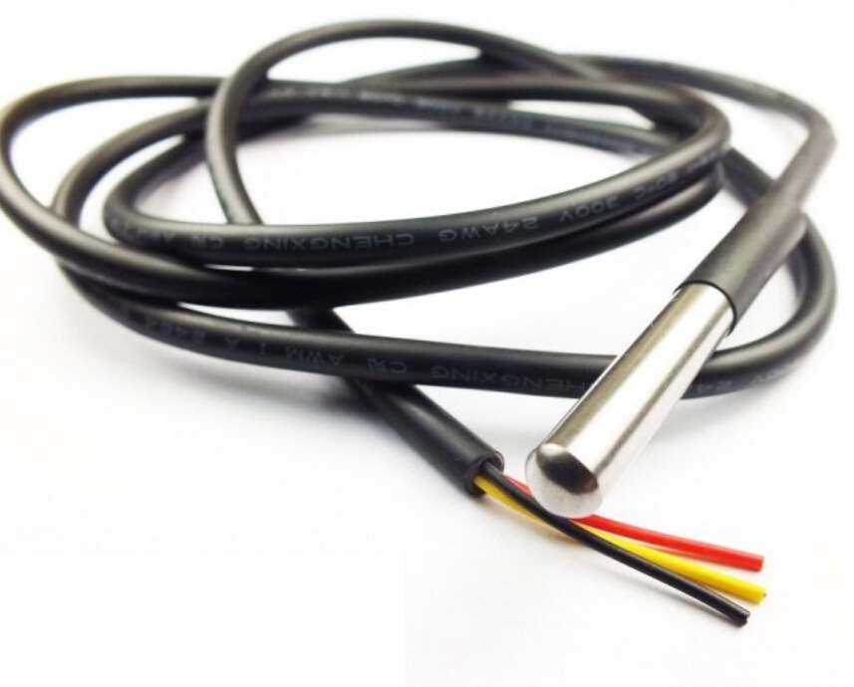

The **DS18B20** is a 1-wire programmable Temperature sensor from maxim integrated. It is widely used to measure temperature in hard environments like in chemical solutions, mines or soil etc. The constriction of the sensor is rugged and also can be purchased with a waterproof option making the mounting process easy. It can measure a wide range of temperature from **-55°C to +125°** with a decent accuracy of **±5°C**. Each sensor has a unique address and requires only one pin of the MCU to transfer data so it a very good choice for measuring temperature at multiple points without compromising much of your digital pins on the microcontroller.

* **DS18B20 Sensor Specifications**
* Programmable Digital Temperature Sensor
* Communicates using 1-Wire method
* Operating voltage: 3V to 5V
* Temperature Range: -55°C to +125°C
* Accuracy: ±0.5°C
* Output Resolution: 9-bit to 12-bit (programmable)
* Unique 64-bit address enables multiplexing
* Conversion time: 750ms at 12-bit
* Programmable alarm options
* Available as To-92, SOP and even as a waterproof sensor

1. **DHT11 sensor**

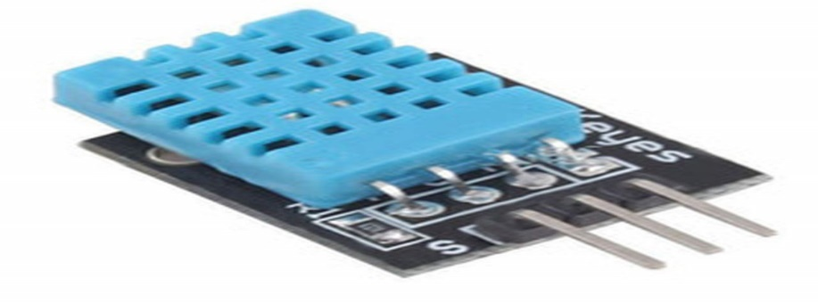

DHT11 is a low-cost digital sensor for sensing temperature and humidity.  This sensor can be easily interfaced with any micro-controller such as Arduino, Raspberry Pi etc… to measure humidity and temperature instantaneously. DHT11 humidity and temperature sensor is available as a sensor and as a module. The difference between this sensor and module is the pull-up resistor and a power-on LED. DHT11 is a relative humidity sensor.  To measure the surrounding air this sensor uses a [thermistor](https://www.elprocus.com/introduction-to-thermistor-types-with-its-workings-and-applications/) and a capacitive humidity sensor. DHT11 sensor consists of a capacitive humidity sensing element and a thermistor for sensing temperature.  The humidity sensing [capacitor](https://www.elprocus.com/construction-of-capacitor-with-working/) has two electrodes with a moisture holding substrate as a dielectric between them. Change in the capacitance value occurs with the change in humidity levels. The IC measure, process this changed resistance values and change them into digital form. For measuring temperature this sensor uses a Negative Temperature coefficient thermistor, which causes a decrease in its resistance value with increase in temperature. To get larger resistance value even for the smallest change in temperature, this sensor is usually made up of semiconductor ceramics or polymers. The temperature range of DHT11 is from 0 to 50 degree Celsius with a 2-degree accuracy. Humidity range of this sensor is from 20 to 80% with 5% accuracy. The sampling rate of this sensor is 1Hz .i.e. it gives one reading for every second.  DHT11 is small in size with operating voltage from 3 to 5 volts. The maximum current used while measuring is 2.5mA. DHT11 sensor has four pins-VCC, GND, Data Pin and a not connected pin. A pull-up resistor of 5k to 10k ohms is provided for communication between sensor and micro-controller.

1. **I2C 16X2 LCD display**

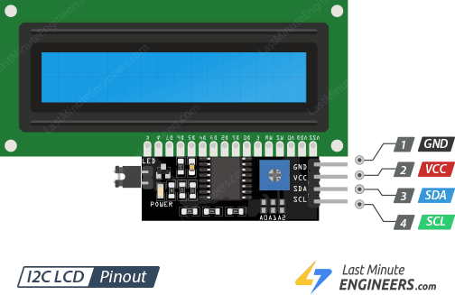

This is a 16x2 LCD display screen with I2C interface. It is able to display 16x2 characters on 2 lines, white characters on blue background. Usually, Arduino LCD display projects will run out of pin resources easily, especially with [Arduino Uno](https://www.dfrobot.com/product-610.html). And it is also very complicated with the wire soldering and connection. This I2C 16x2 Arduino LCD Screen is using an I2C communication interface. It means it only needs 4 pins for the [LCD](https://www.dfrobot.com/category-130.html) display: VCC, GND, SDA, SCL. It will save at least 4 digital/analog pins on [Arduino](https://www.dfrobot.com/topic-277.html). All connectors are standard XH2.54 (Breadboard type). You can connect with the [jumper wire](https://www.dfrobot.com/product-356.html) directly.

* Specification
* Compatible with Arduino/Genuino [UNO](https://www.dfrobot.com/product-838.html), [Leonardo](https://www.dfrobot.com/product-832.html), [Mega](https://www.dfrobot.com/product-1175.html), 101 (Intel Curie), Micro, [Nano](https://www.dfrobot.com/product-1122.html), Mini
* I2C Address:0x20-0x27(0x20 default)
* Back lit (Blue with white char color)
* Supply voltage: 5V
* Interface:I2C/TWI x1,Gadgeteer interface x2
* Adjustable contrast
* Size: 80x36x20mmz(3.1x1.4x0.7in)

1. **ECG**

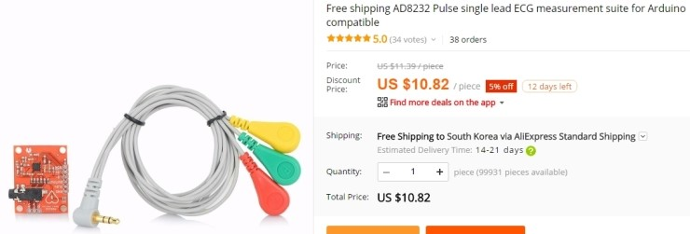

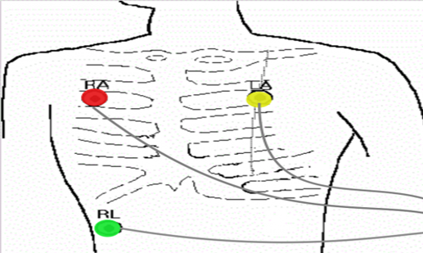

ECG records the electrical activity generated by heart muscle depolarizations, which propagate in pulsating electrical waves towards the skin. Although the electricity amount is in fact very small, it can be picked up reliably with ECG electrodes attached to the skin. The full ECG setup comprises At least Three electrodes which are placed on the chest or at the four extremities according to Standard nomenclature (RA = right arm; LA = left arm; RL = right leg). Of course, Variations of this setup exist to allow more flexible and less intrusive recordings, for example, by attaching the electrodes to the forearms and legs. ECG electrodes are typically wet sensors, requiring the use of a conductive gel to increase conductivity between skin and electrodes.

# **Software requirement**

1. **Arduino software (IDE)**

The Arduino Integrated Development Environment ([IDE](https://en.wikipedia.org/wiki/Integrated_development_environment)) is a [cross-platform](https://en.wikipedia.org/wiki/Cross-platform) application (for [Windows](https://en.wikipedia.org/wiki/Windows), [macOS](https://en.wikipedia.org/wiki/MacOS), [Linux](https://en.wikipedia.org/wiki/Linux)) that is written in functions from [C](https://en.wikipedia.org/wiki/C_(programming_language)) and [C++](https://en.wikipedia.org/wiki/C%2B%2B_(programming_language)). It is used to write and upload programs to [Arduino](https://en.wikipedia.org/wiki/Arduino) compatible boards, but also, with the help of third-party cores, other vendor development boards.

1. **Blynk**

Blynk is a Platform with IOS and Android apps to control Arduino, Raspberry Pi and the likes over the Internet. It's a digital dashboard where you can build a graphic interface for your project by simply dragging and dropping widgets.

1. **Ubidots**

Ubidots is an Internet of Things (IoT) data analytics and visualization company. Ubidots technology and engineering stack was developed to deliver a secure, white-glove experience for users. Device friendly APIs (accessed over HTTP/MQTT/TCP/UDP protocols) provide a simple and secure connection for sending and retrieving data to and from our cloud service in real-time. Ubidots’ time-series backend services are performance optimized for IoT data storage, computation, and retrieval.

1. **IFTTT**

IFTTT derives its name from the programming conditional statement “if this, then that.” What the company provides is a software platform that connects apps, devices and services from different developers in order to trigger one or more automations involving those apps, devices and services.

# **Designing**

# **Circuit Diagram**

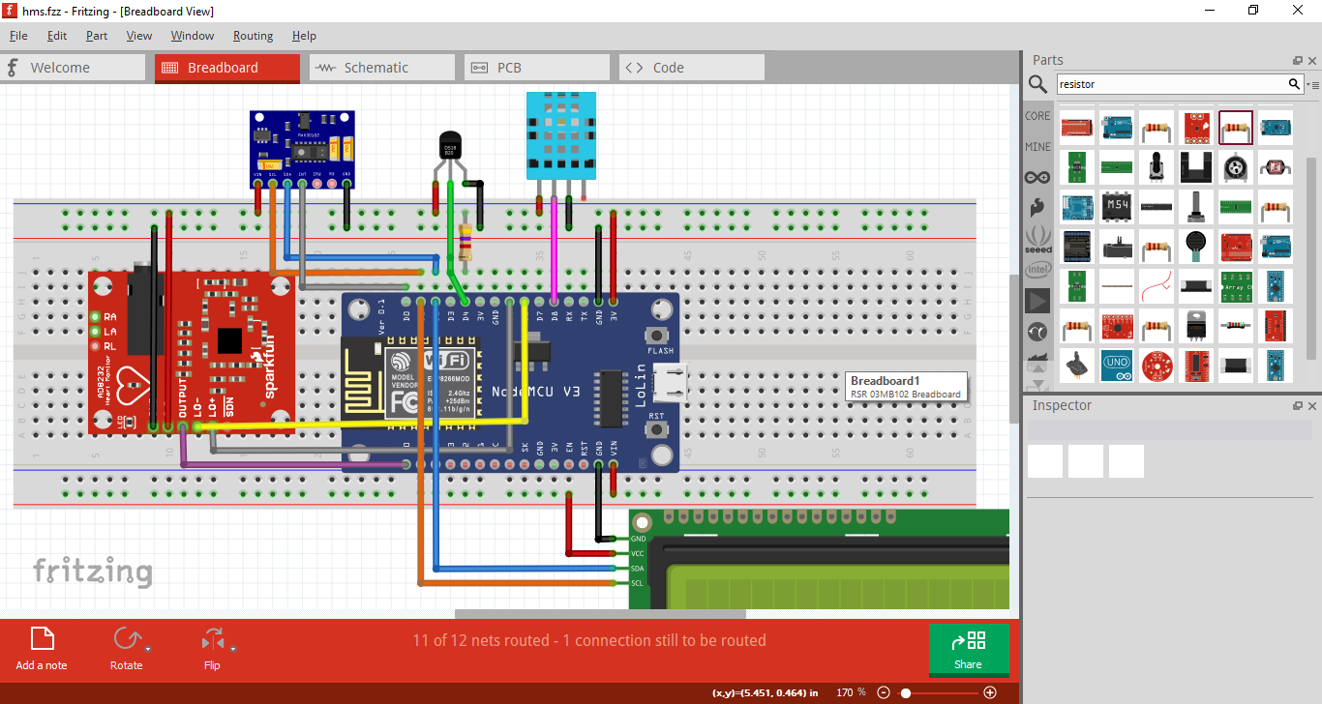

**Figure no: - 5.1.1 Circuit Diagram of health monitoring system**

# **Flow Chart**

Start

Connect to Wi-Fi

No

If wifi available?

Yes

Read all sensor data such as body temperature, spo2, heart rate, ECG, air temperature, humidity

Temperature, spo2, heart rate are abnormal?

Yes

Send email to doctor using blynk app

Sending data over cloud

Display on LCD display

Display on iot platform such as blynk, ubidots Google sheet, etc.

**Figure No.: - 5.2.1 flow chart of health monitoring system**

# **Block diagram**

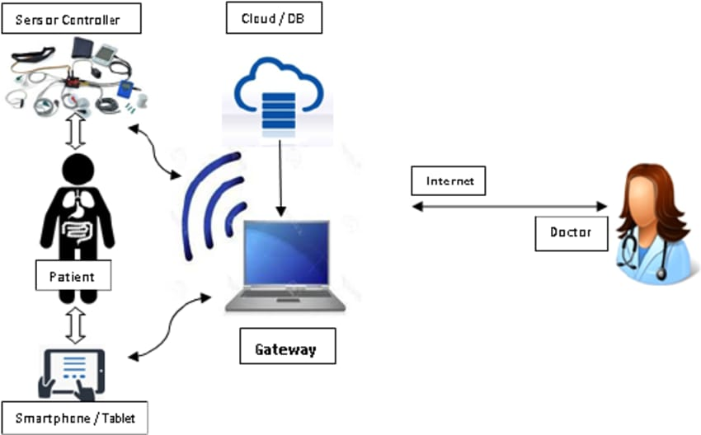

**Figure No. 5.3.1 block diagram of health monitoring system using IoT**

In these Health monitoring system, each sensor will perform their respective working at a time. All these sensor data goes to the nodemcu esp8266 WiFi module. Esp8266 nodemcu module process the code. And display on LCD display and Android (using iot platform) such as blynk so that patient health can be monitored doctor from anywhere in the world over internet.

# **Result and Applications**

# **Result**

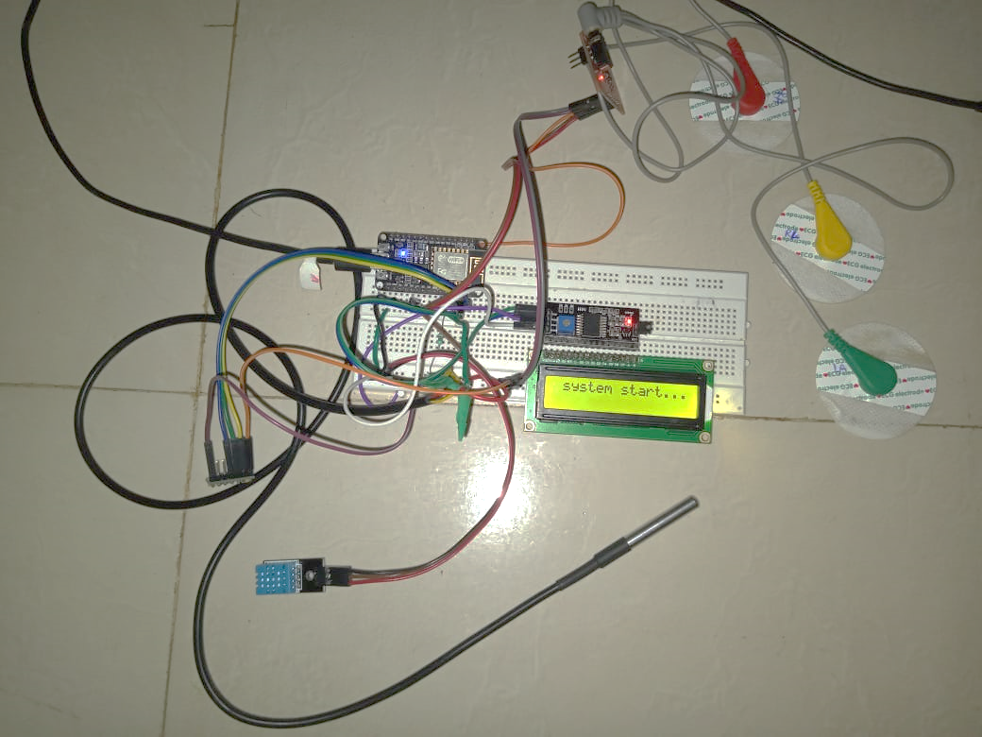

**Figure No 6.1.1: - Actual project model**

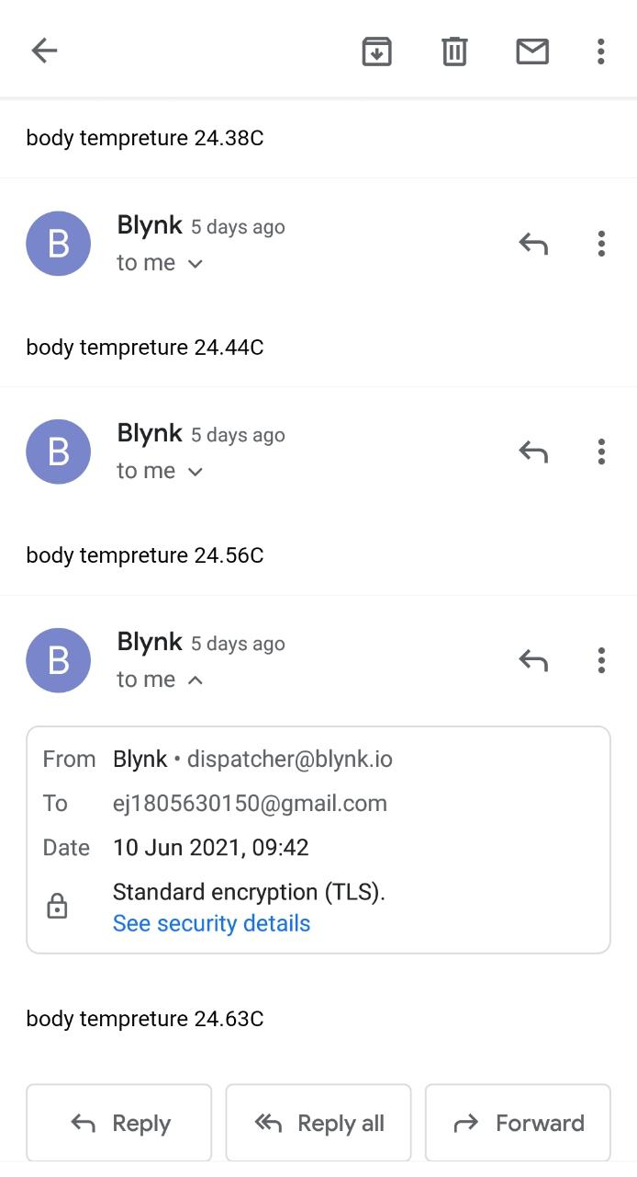

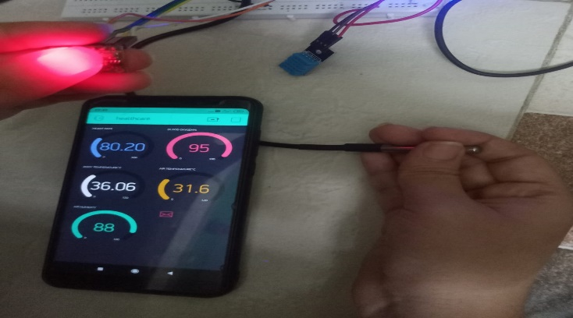

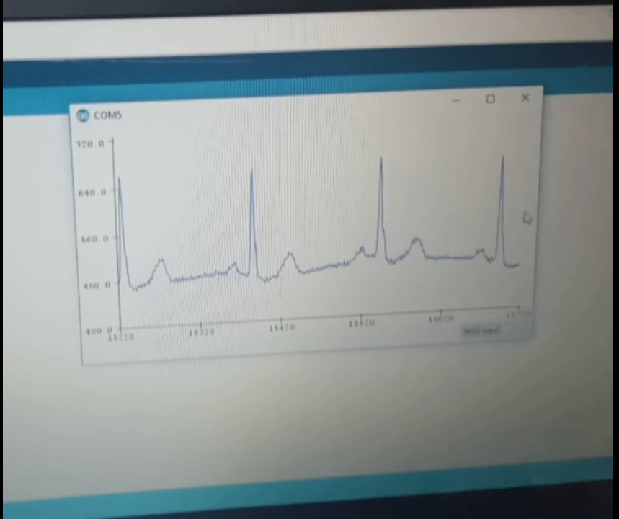**Figure No 6.1.2:- Output of Sensor reading Figure No 6.1.3:- email alert**

**Figure No 6.1.3: ECG output**

# **Applications**

Health monitoring system using iot project have various applications in medical industry for improving the quality of life, saving lives and reduce treatment cost. By using IoT based technologies, medical industry can improve the ability of the healthcare system in minimizing human error, simplifying the treatment process and quality of life for caregiver as well patient. IoT based monitoring system can help doctors in treatments and predict a symptom before starting diagnosis. Monitoring system can also alarm in medical emergency situations like falling of old age patient ,patient has abnormal behavior as in the intensive care unit (ICU).There are many IoT based healthcare use cases/application area as follows:

* Health Monitoring
* Personal Fitness Monitoring
* Chronic Disease Monitoring
* Safety Monitoring
* Medication Monitoring
* Home Rehabilitation
* Best to be used on rural areas.

# **Conclusion and Future Scope**

# **Conclusion**

An efficient health monitoring system is developed to monitor the up to date status of the patient irrespective of the presence of the doctor. The system collects information like body temperature, ECG and pulse oximeter of the patient and updates the same to the doctor. The doctor can monitor the progress of patients' health now and then to advise them about their health.IOT Health care is the most demanding field in the medical area. As health care services are important part of our society, automating these services lessen the burden on humans and eases the measuring process. Also the transparency of this system helps patients to trust it. The objective of developing monitoring systems is to reduce health care costs by reducing physician office visits, hospitalizations, and diagnostic testing procedure. The IoT technology helps the server to update the patient data on website or app. Many further improvements can be made in our system to make it better and easily adaptable such as adding more advanced sensors. The biometric information of the patient which is stored and published online can be given to scientists and researchers of medical fields to analyze the value and find patterns or for other research work. To simplify the hardware and reduce wiring we can use wireless sensors.

More important fact that came up during project design is that all the circuit components used in the remote health detection system are available easily. The Remote Health monitoring system utilizes these concepts to come up with a system for better quality of life for people in society. From an engineering perspective, the project has seen concepts acquired through the computer science and embedded study period being practically applied. The Electric circuit analysis knowledge was used during design and fabrication of the individual modules.

# **7.2 Future scope:**

* The whole health monitoring system, which we have proposed can be integrated into a small compact unit as small as a cell phone or a wrist watch. This will help the patients to easily carry this device with them wherever they go.
* We can add multiple features in these system like lung capacity sensors, GSR sensor, EEG sen0sor, accelerometer sensor and patient room monitoring system is also added in the future to check air quality etc.
* In future we can add a graphical LCD can be used to display a graph of rate of change of health parameters over time.
* We can add a GPS module in IOT patient monitoring using WiFi module project. This GPS module will find out the position or the location of the patient using the longitude and latitude received. Then it will send this location to the cloud that is the IOT using the Wi-Fi module. Then doctors can find out the position of the patient in case they have to take some preventive action.
* Remote viewing of data Problems associated with having data online. Tackle Distributed denial of service. DDOS, and Data privacy/security especially of medical systems.

# **Appendix**

|  |  |  |  |  |  |  |  |
| --- | --- | --- | --- | --- | --- | --- | --- |
|  | Activity | AUG 2020  To  NOV 2021 | NOV 2021 TO  FEB 2021 | FEB 2021  TO  MAR 2021 | MAR 2021  TO  APR 2021 | APR 2021  TO  MAY 2021 | MAY 2021  TO  JUN 2021 |
| SR. NO. | Dates | 19/08/2020To  19/11/2020 | 19/011/2020 To  19/02/2021 | 19/02/2021 To  19/03/2021 | 19/03/2021 To  05/04/2021 | 05/04/2021 To  05/05/2021 | 05/05/2021To 05/06/2021 |
| 1. | **Preliminary investigation** |  |  |  |  |  |  |
|  |  |
|  |  |
| 2. | **System Analysis** |  |  |  |  |  |  |
|  |  |
|  |  |
| 3. | **System**  **Design** |  |  |  |  |  |  |
|  |
|  |
| 4. | **System Coding** |  |  |  |  |  |  |
|  |
|  |
| 5. | **Testing** |  |  |  |  |  |  |
|  |
|  |

# **References and Bibliography**

# **Reference**

* [Development of Smart Healthcare Monitoring System in IoT Environment | SpringerLink](https://link.springer.com/article/10.1007/s42979-020-00195-y)
* [IoT Based Patient Health Monitoring using ESP8266 & Arduino (how2electronics.com)](https://how2electronics.com/iot-patient-health-monitoring-system-esp8266/)
* [An IoT based Patient Health Monitoring System | IEEE Conference Publication | IEEE Xplore](https://ieeexplore.ieee.org/document/8441708)
* [IoT in Healthcare: Benefits, Use Cases, Challenges [Guide] (intellectsoft.net)](https://www.intellectsoft.net/blog/iot-in-healthcare/)

# **Bibliography**

* An IoT based Patient Health Monitoring System: D. Shiva Rama Krishnan, Subhash Chand Gupta, Tanupriya Choudhury and publisher: IEEE
* Handbook of Research on Biomedical Engineering Education and Advanced Bioengineering Learning: Interdisciplinary Concepts Sverre Grimnes (University of Oslo, Norway & Oslo University Hospital Rikshospitalet, Norway) and Jan Olav Høgetveit (University of Oslo, Norway & Oslo University Hospital Rikshospitalet, Norway)
* Health Monitoring System Using IoT: A. Selvanayakam, A. C. Varishnee, M. Kalaivani, G. Ranjithkumar
* The inernet of things with esp8266 Hands on approach get started with Arduino IDE and ESP8266: Mr Magesh Jayakumar